Testing basics
Scrum
Selenium
TestNG
Java
Appium
GIT
API Testing
CI/CD
AI
AWS
Desarrollo de modelos de razonamiento
Differences between agentic vs agentic for IA
Context model protocol
Permiso cores
Get way
Test 10 instances and show what is failing
Name not found
How to verify if the developer is managing correctly the status codes.

dependencies injection.
Shadow DOM in Selenium.
Utilizar sprint boot.

Testing basics
- Test case
- Types of testing
- Test scenario
- Test plan
- Test Lifecycle
- Bug Lifecycle
- Types of testing
- Test driven Development
- Xpath types

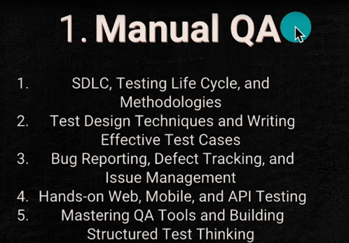
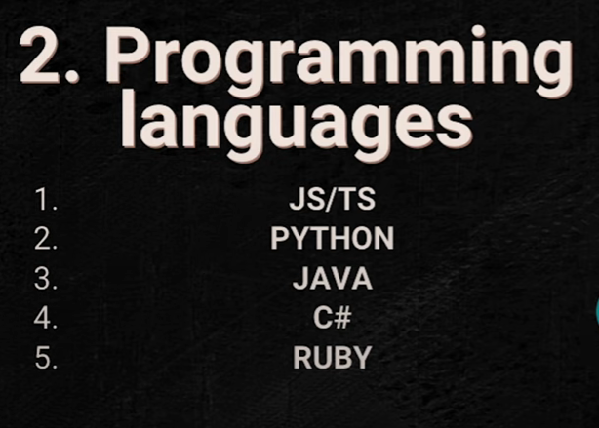

Test case
A documented set of conditions and steps that represent a user interaction with a specific software functionality

Test scenario
Is a high-level/General overview of what to test— that can describes a functionality or user flow that needs a validation. It focuses on ‘what’ we are testing from the user’s perspective. For example
Verify login functionality using different credential combinations.
- TC_Login_Valid - TC_Login_InvalidPassword - TC_Login_SQLInjection - TC_Login_EmptyFields

Test life cycle
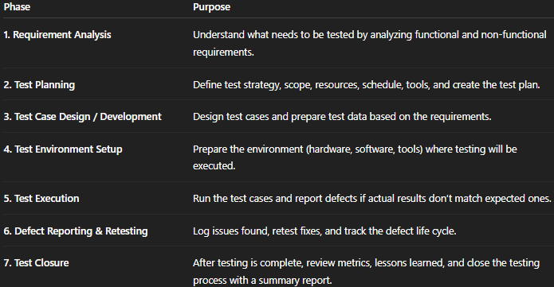

Bug
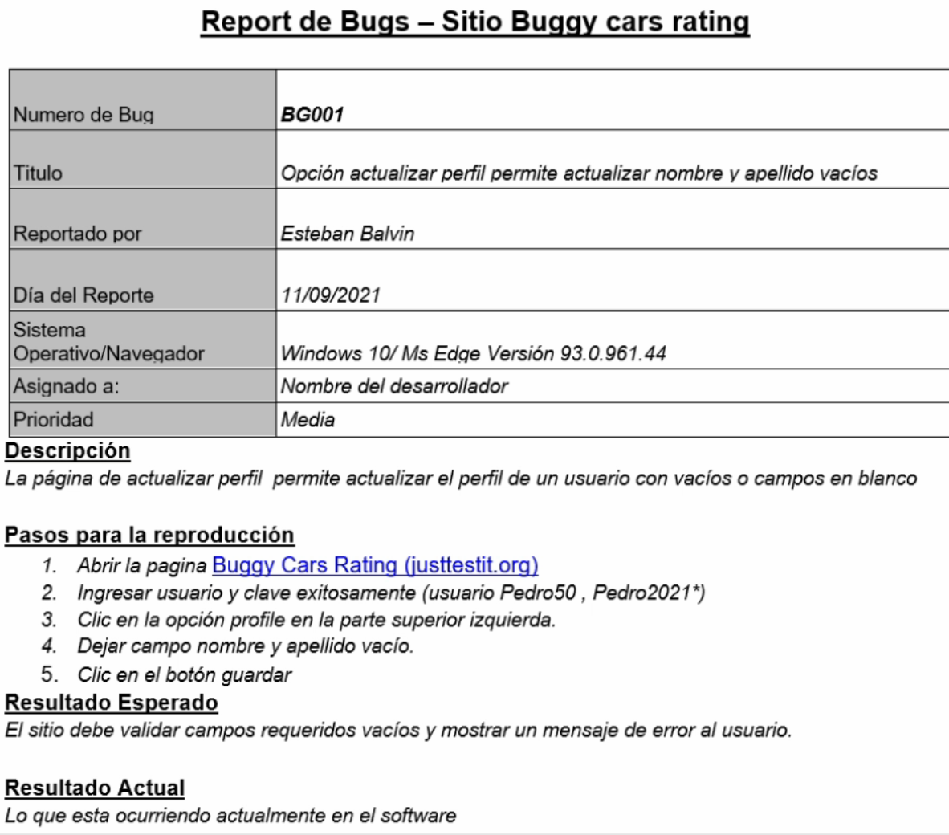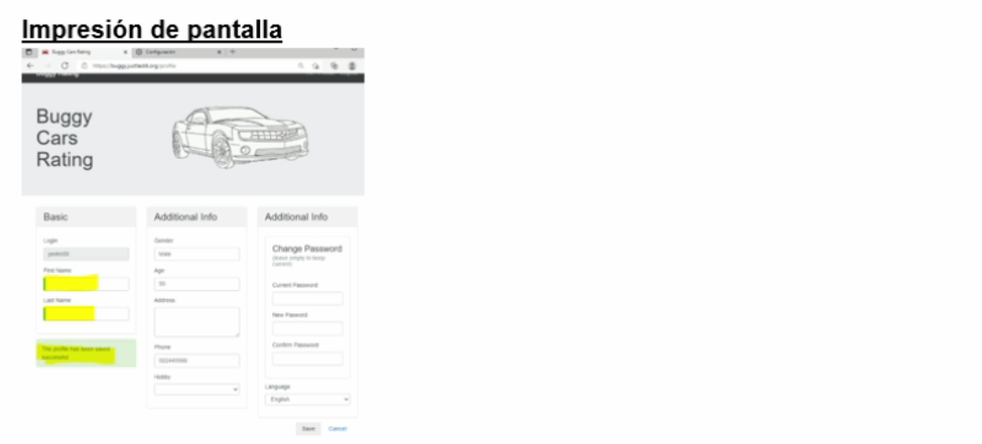

Bug Lifecycle
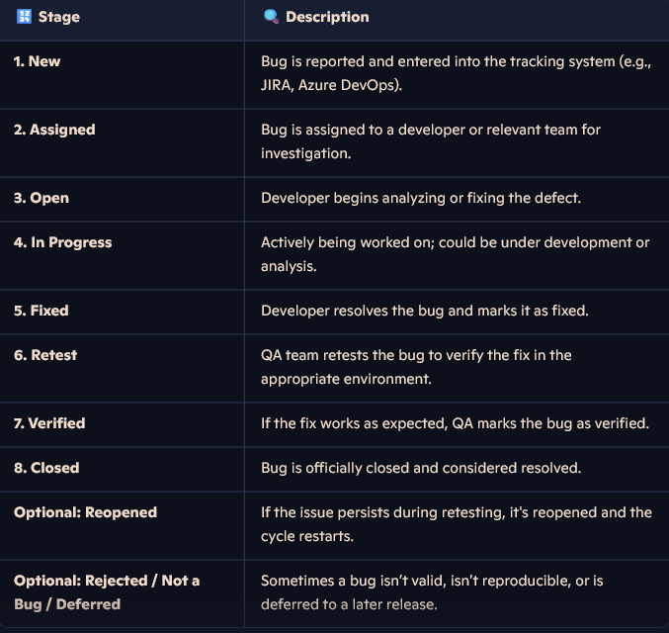

BDD
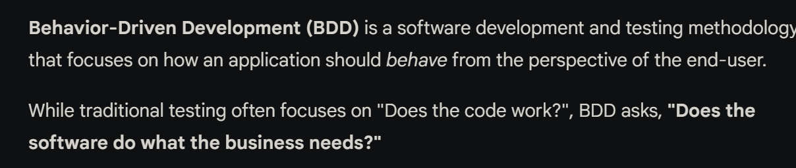
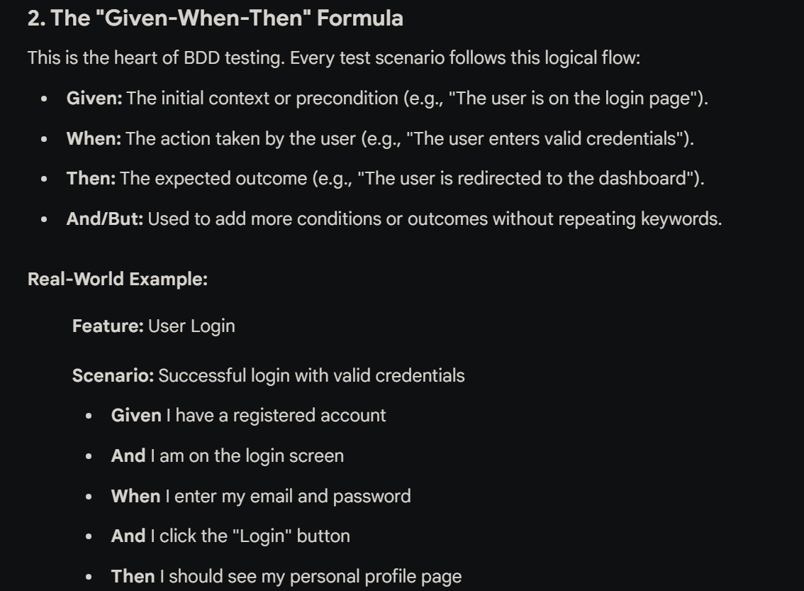

Test plan
A test plan is a strategic document that guides the QA team through the testing process. It represents what will be tested, how it will be tested, who will perform the testing, and the schedule.
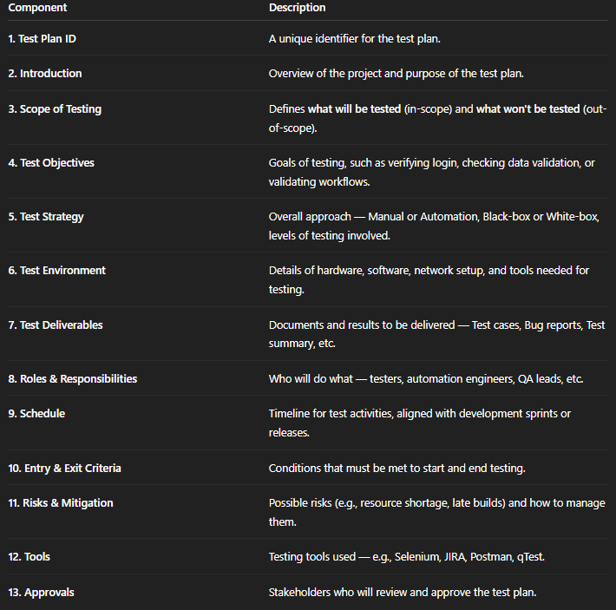

SCRUM
- What iSCRUM
- Ceremonies

Ceremonies
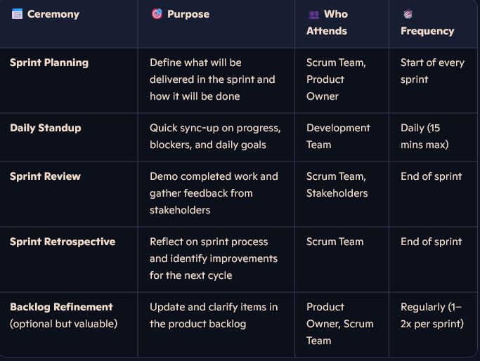

Selenium
Classes
- Login
- Locators
- Exceptions
- What is Selenium
- Waits in selenium
- Xpath types
- CSS Selectors
- Page Object Model (POM)
- Locators
- Class of locators
- Data driven testing (DDT)
- Iframes
- Not such element ex and stale elemt execption
- Difference between driver.close() and driver.quit()
- Explain the different components of Selenium.
- How do you handle synchronization issues in Selenium?
- What is TestNG, and how can it be integrated with Selenium?
- Explain the concept of Test Data in Selenium. How do you manage test data effectively?
- Pop ups and
- Maven
- Selenium conponents
- Levels of testing
- findElement() vs findElements()
- Handle dynamic elements or elements with dynamic IDs
- What are the advantages of using Selenium WebDriver over Selenium RC?
- What are the different types of waits available in Selenium WebDriver?
- Handle dropdowns or select options
- Multiple windows
- How do you handle browser cookies in Selenium?
- What are the benefits of using TestNG over JUnit for test automation?
- File uploads

- Can you explain the process of taking screenshots in Selenium?

Java
- What is POO
- Class
- Methods
- Constructor
- Encapsulation
- Anbstraction
- Inheritance
- Solid principles
- DRY principle
- BDD and TDD
- Exercices
- Overriding and Overloading

POO
Object, attribute, method, Class, instancy

TestNG

Api testing

  - API and restAPI
  - Test Types

  - HTTP Status code families
  - HTTP METHODs
  - Components
  - Pagination

Appium
  - Setup
  - Getures touch actions
  - HTTP Status code families
  - HTTP METHODs
  - Components

GIT

Git commands
  - Git init – Initializes a new Git repository in your project folder
  - Git checkout new-branch: Switches to another branch or restores files.
  - Git clone <repository-url> - Copies an existing Git repository (usually from GitHub or GitLab) to your local machine.
  - Git add <file> or . : Stages changes to be committed.
  - Git Status: Shows the current state of your working directory and staging area.
  - Git Commit -m “msg”: Saves your staged changes to the repository with a message
  - Git pull -rebase origin development: Fetches and merges changes from a remote repository into your local branch.
  - Git push -f origin: Uploads your committed changes to a remote repository
  - Git --amend: Lets you modify your most recent commit — perfect for fixing typos, adding missed files, or updating the commit message without creating a new commit.

  - Git merge : Combines one branch into another (usually into main or master).
  - Git branch: List branches
  - Git branch new-branch: Create branch
  - Git log: Shows a log of all commits the current branch

Appium Drivers

In select class we have trhee methods associated with it select by index, by visible text
Overriding and overloading methods
Constructor overloading and what are the different constructors in java

Class

Methods
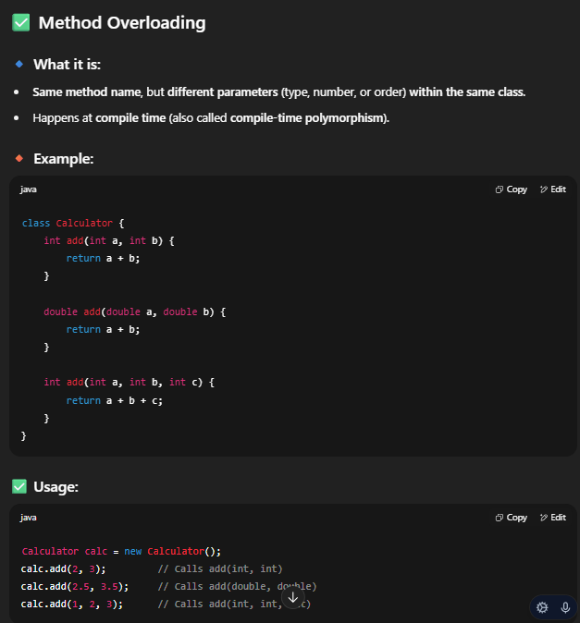

Method Overriding
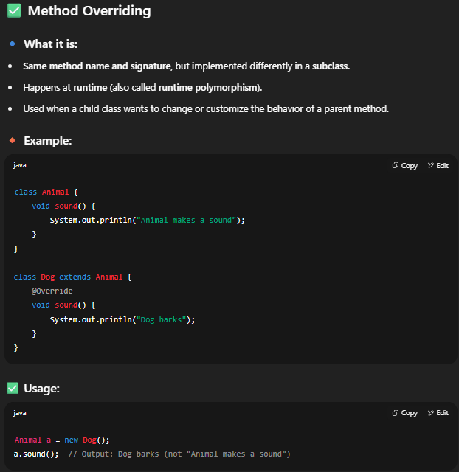
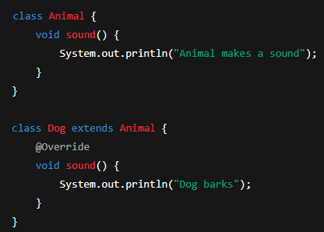

Constructor
A constructor is a special method in a class that is automatically called when an object is created. It’s used to initialize the object, often by setting initial values.
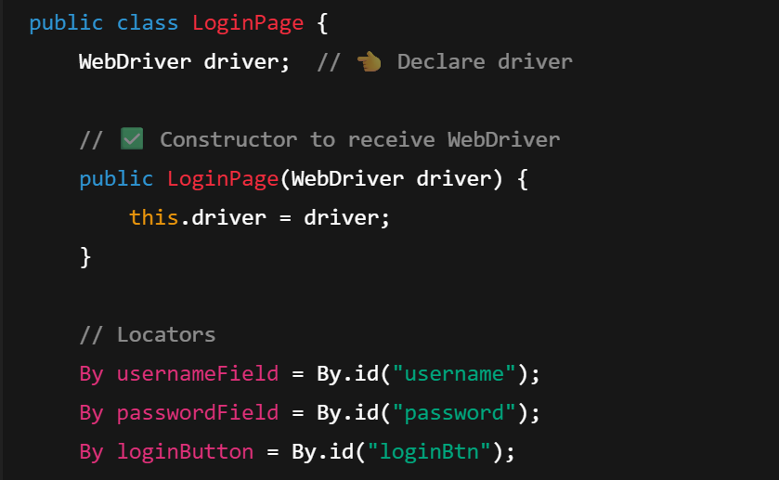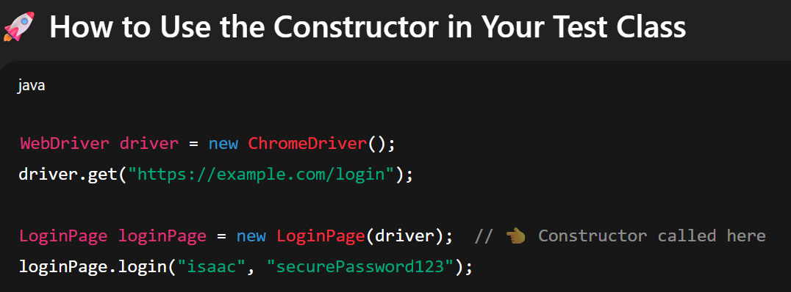

Encapsulation
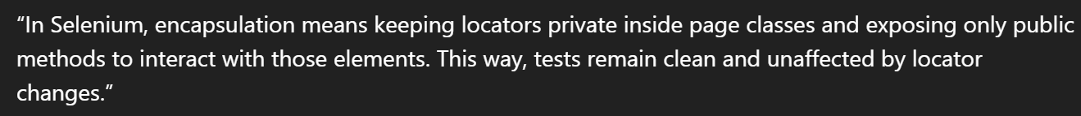
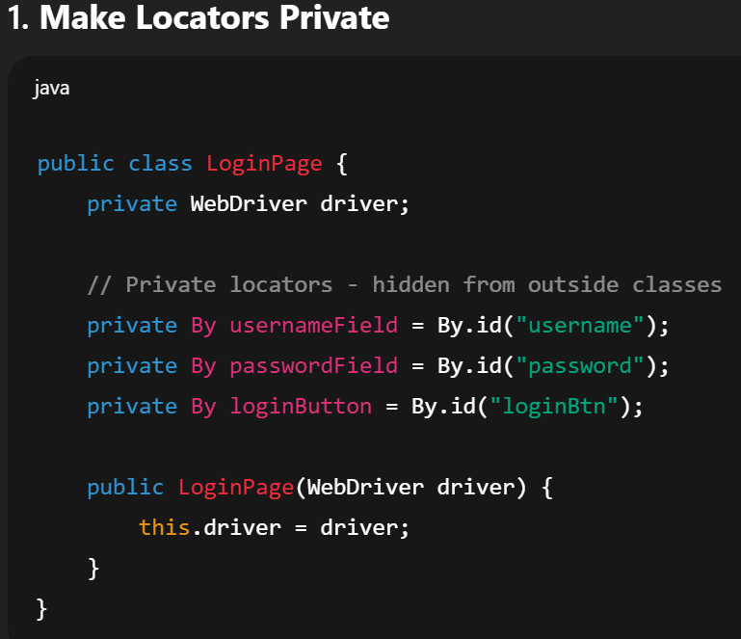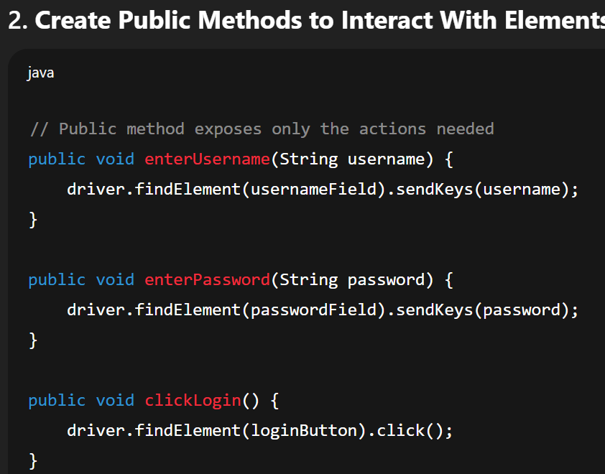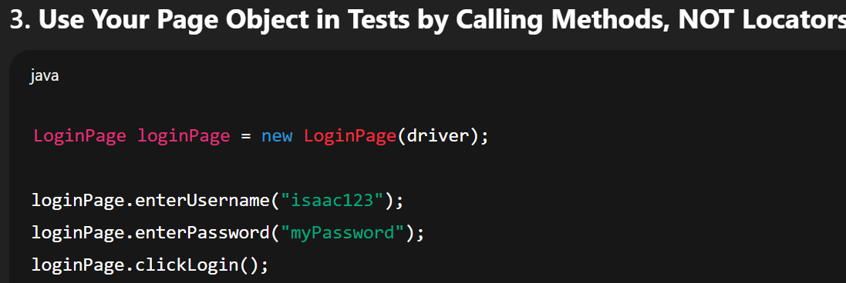

Abstraction
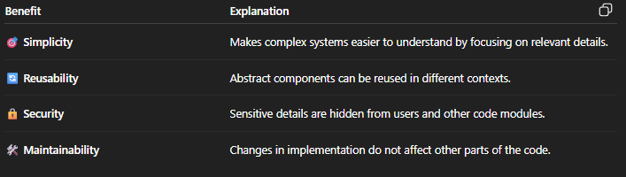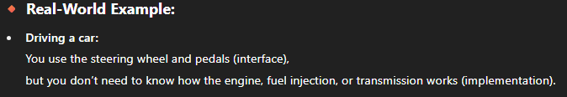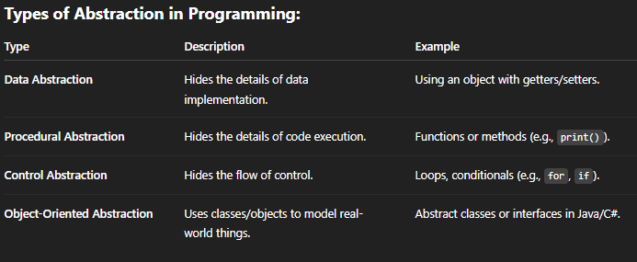
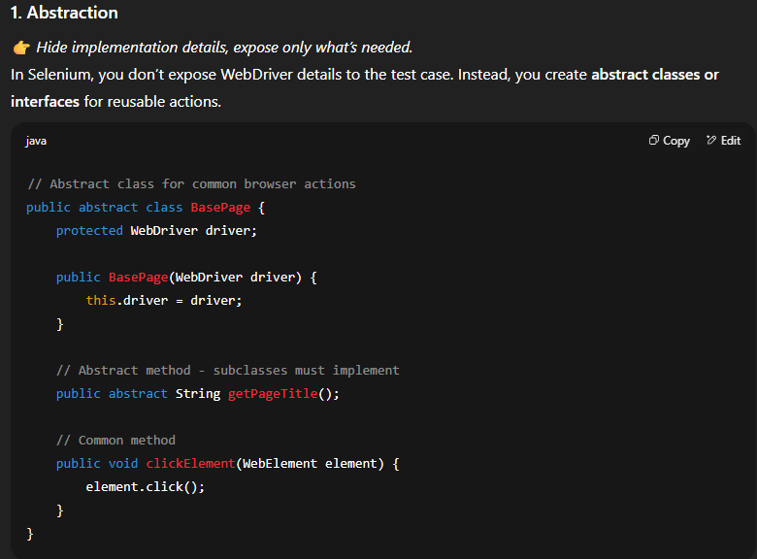

Solid principles
Single Responsibility Principle (SRP)
Open/Closed Principle
Liskov Substitution Principle
Interface Segregation Principle
Dependency Inversion Principle
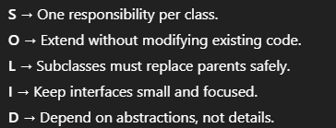
Single Responsibility Principle (SRP)
- A class should only have one reason to change.
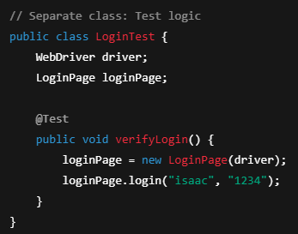
- Don’t mix test logic, page actions, and driver setup in the same class.
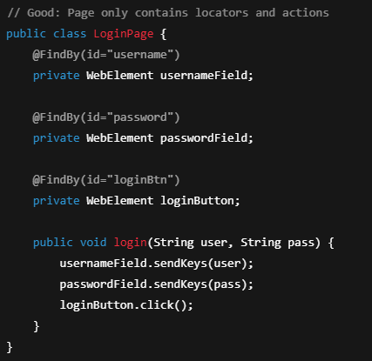

Open/Closed Principle
- Classes should be open for extension but closed for modification.
- You can add new functionality without changing existing tested code.
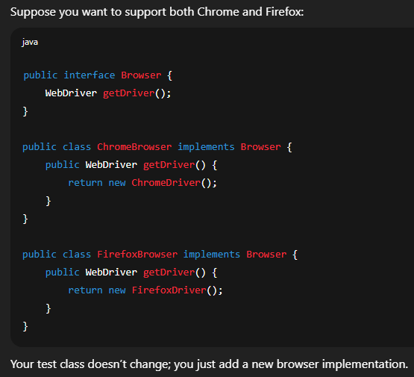

Liskov Substitution Principle
Subclasses should be replaceable by their parent class without breaking the system.
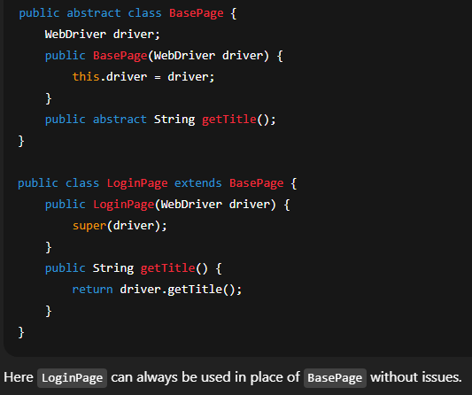

Interface Segregation Principle
- Don’t force a class to implement methods it doesn’t use.
- Prefer smaller, specific interfaces.
- Now, a Button class can implement only Clickable, while a TextBox can implement TextField.
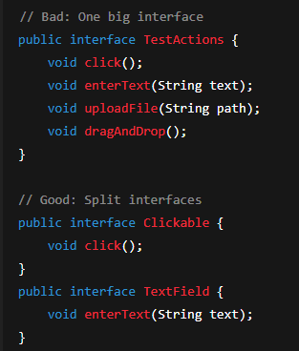

Dependency Inversion Principle
- Depend on abstractions, not on concrete classes.
- Makes your framework more flexible.
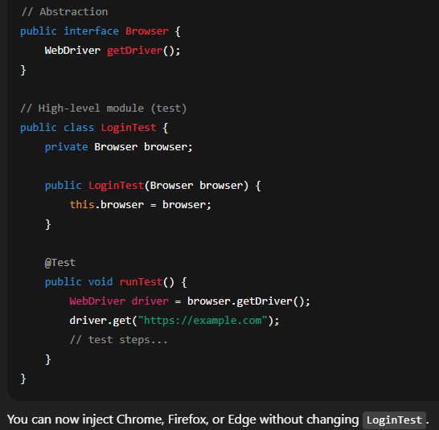

DRY principle
DRY stands for Don’t Repeat Yourself.
It’s a programming principle that means:
Every piece of knowledge or logic should exist in only one place in your code.
If you repeat the same code in multiple places, it becomes hard to maintain. If something changes, you’ll have to update it everywhere, which increases the risk of bugs.
Why is it important?
- Keeps your code cleaner and easier to read.
- Makes your code easier to maintain (change in one place, affects everywhere).
- Reduces bugs caused by inconsistent changes.
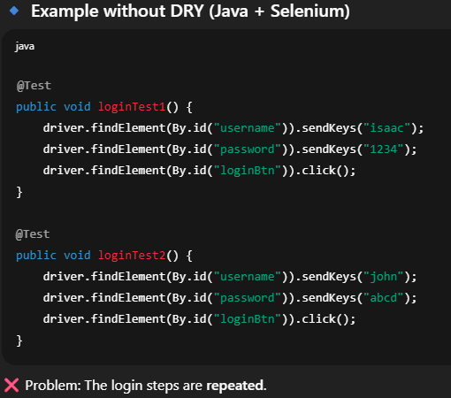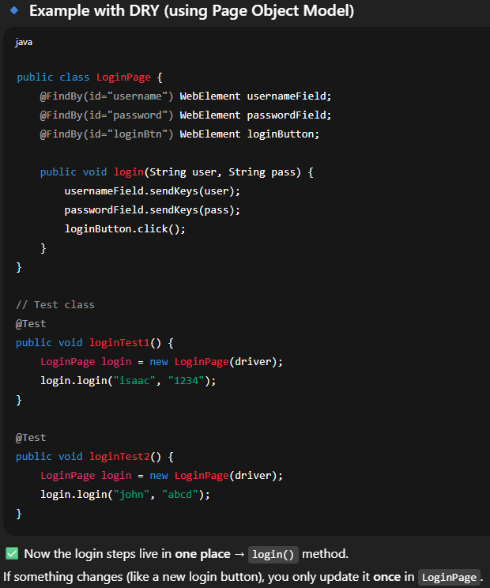

BDD and TDD

BDD (Behavior Driven Development)
TDD
BDD It’s a software development approach that focuses on how the system should behave from the perspective of the end user, instead of only focusing on technical details.
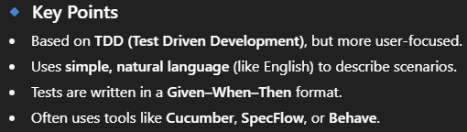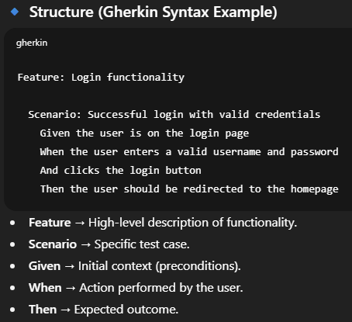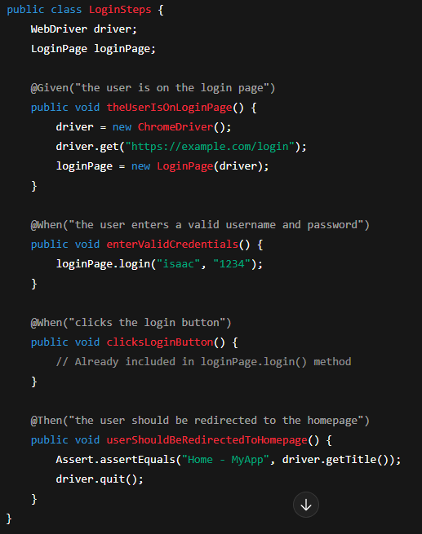

TDD
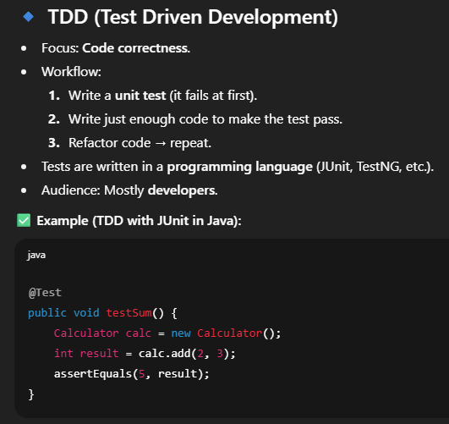

Exercices
    - First and last register of an array
    - Reverse of an array
    - Is duplicated
    - Remove duplicated
    - Group list of articles by location array

First and last register
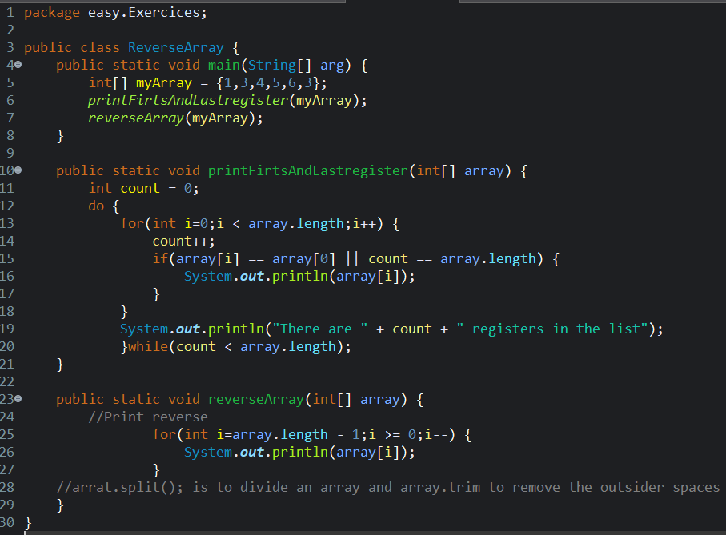

Is duplicated
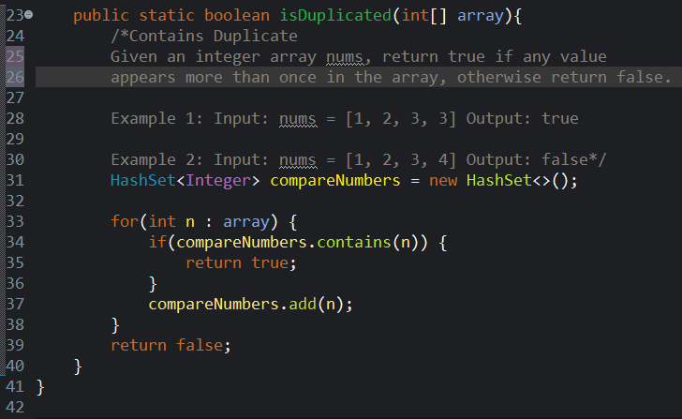

Remove Duplicated
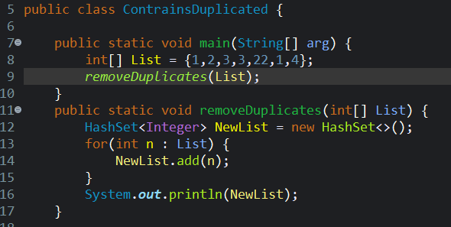

Group list of articles by location array
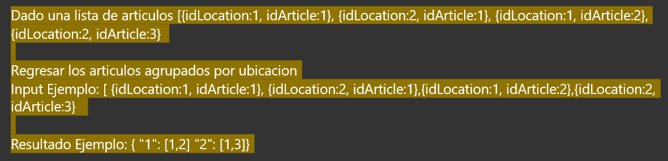
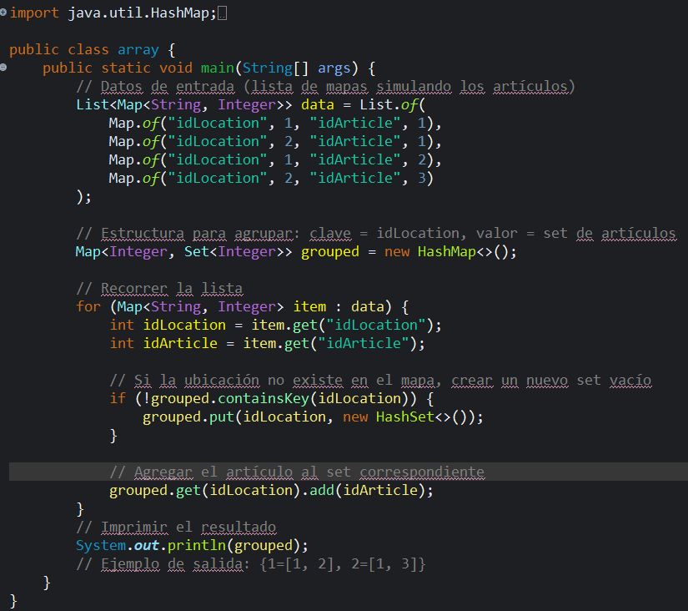

Overloading and overriding

Difference between array List and array:
Array list has a dynamic size we can increase by adding or decrease by removing the data while an array is completely static and, we might not be able to increase it’s length.
Static method vs final method
Interfaces in Java
Superclass and subclass

CI/CD

AI
Github copilot
GitHub Copilot is an AI-powered coding assistant developed by GitHub in collaboration with OpenAI (and Microsoft).
It works inside your IDE (Visual Studio Code, Visual Studio, JetBrains, Neovim, etc.) or in other interfaces (like GitHub web via chat) to help you write code faster and with less effort.
Copilot is often described as an “AI pair programmer” — it suggests lines, blocks, or even whole functions based on your nClasses
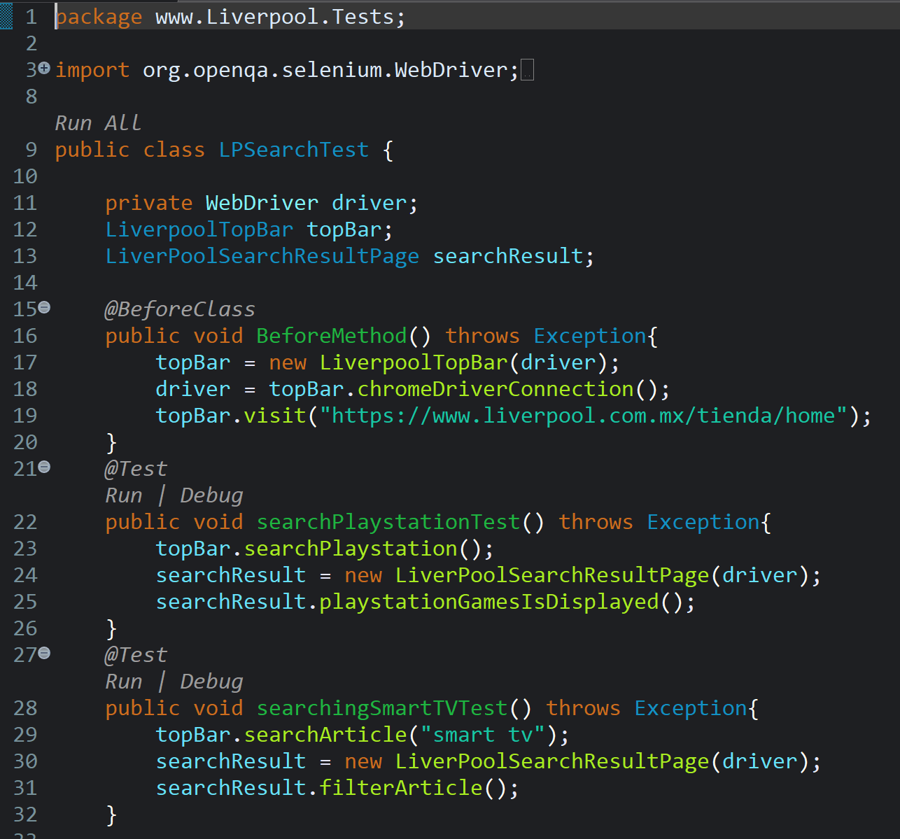
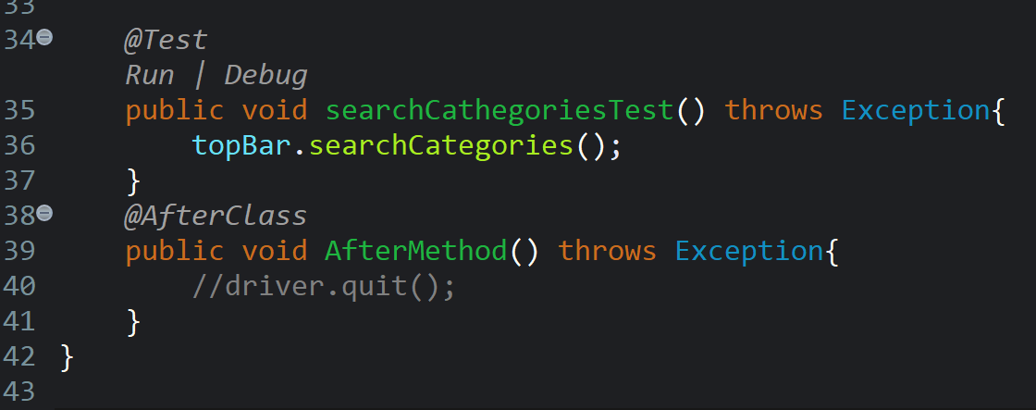

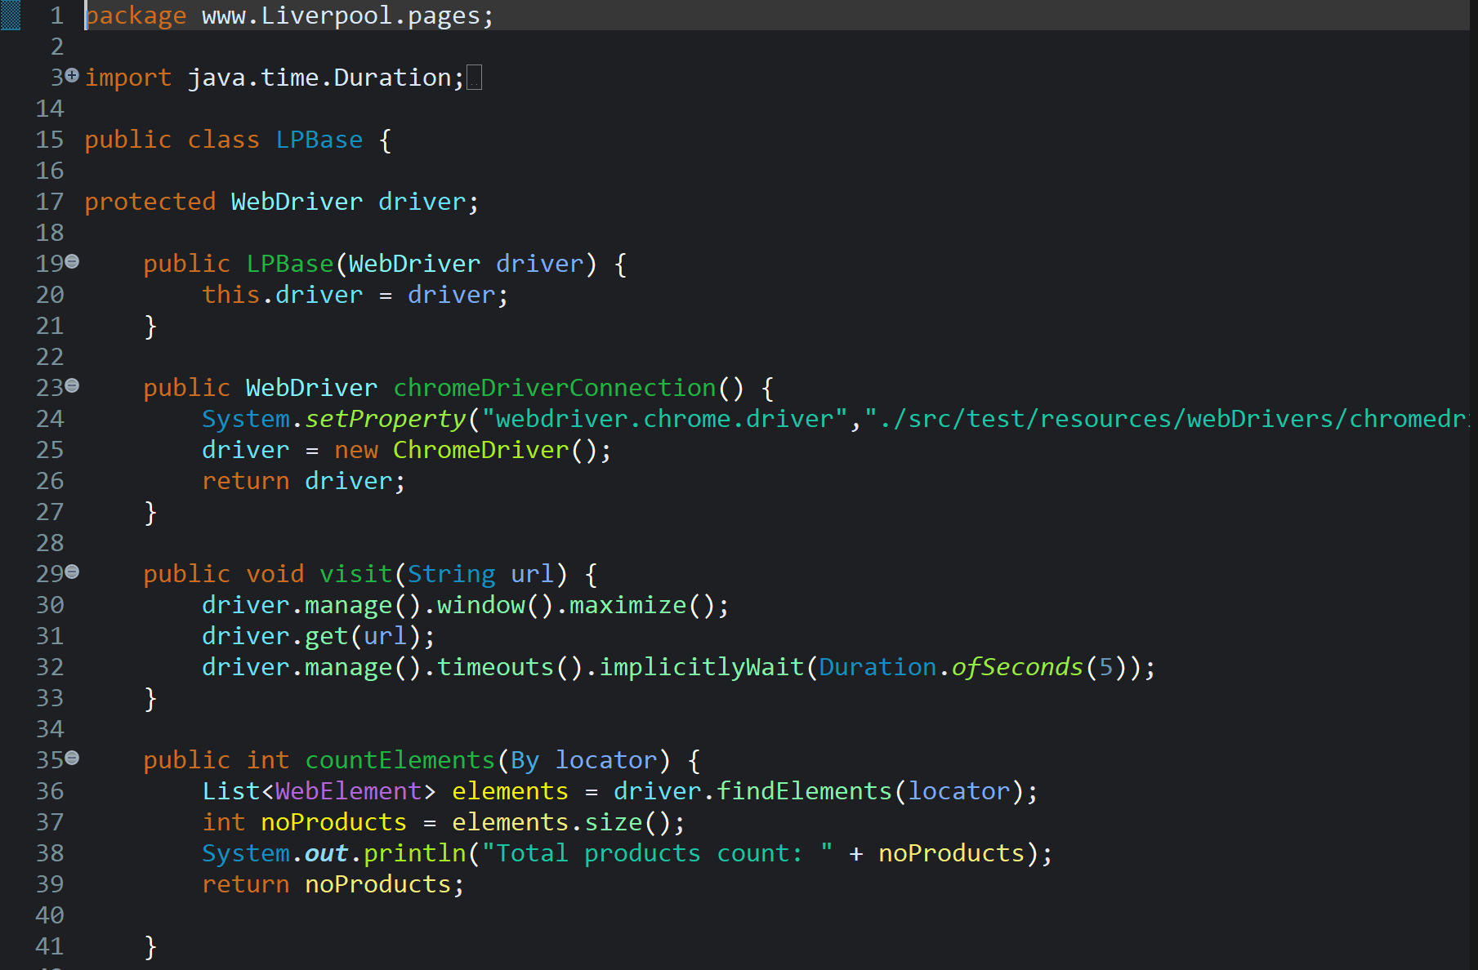
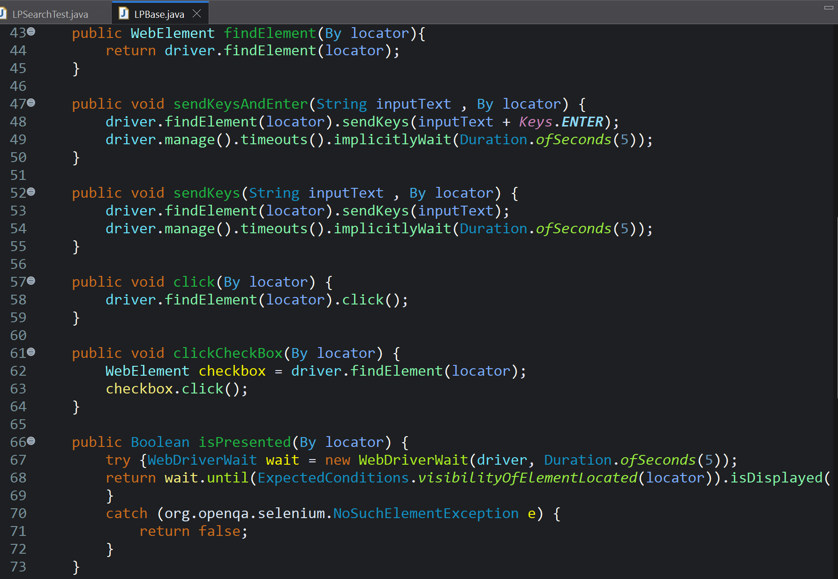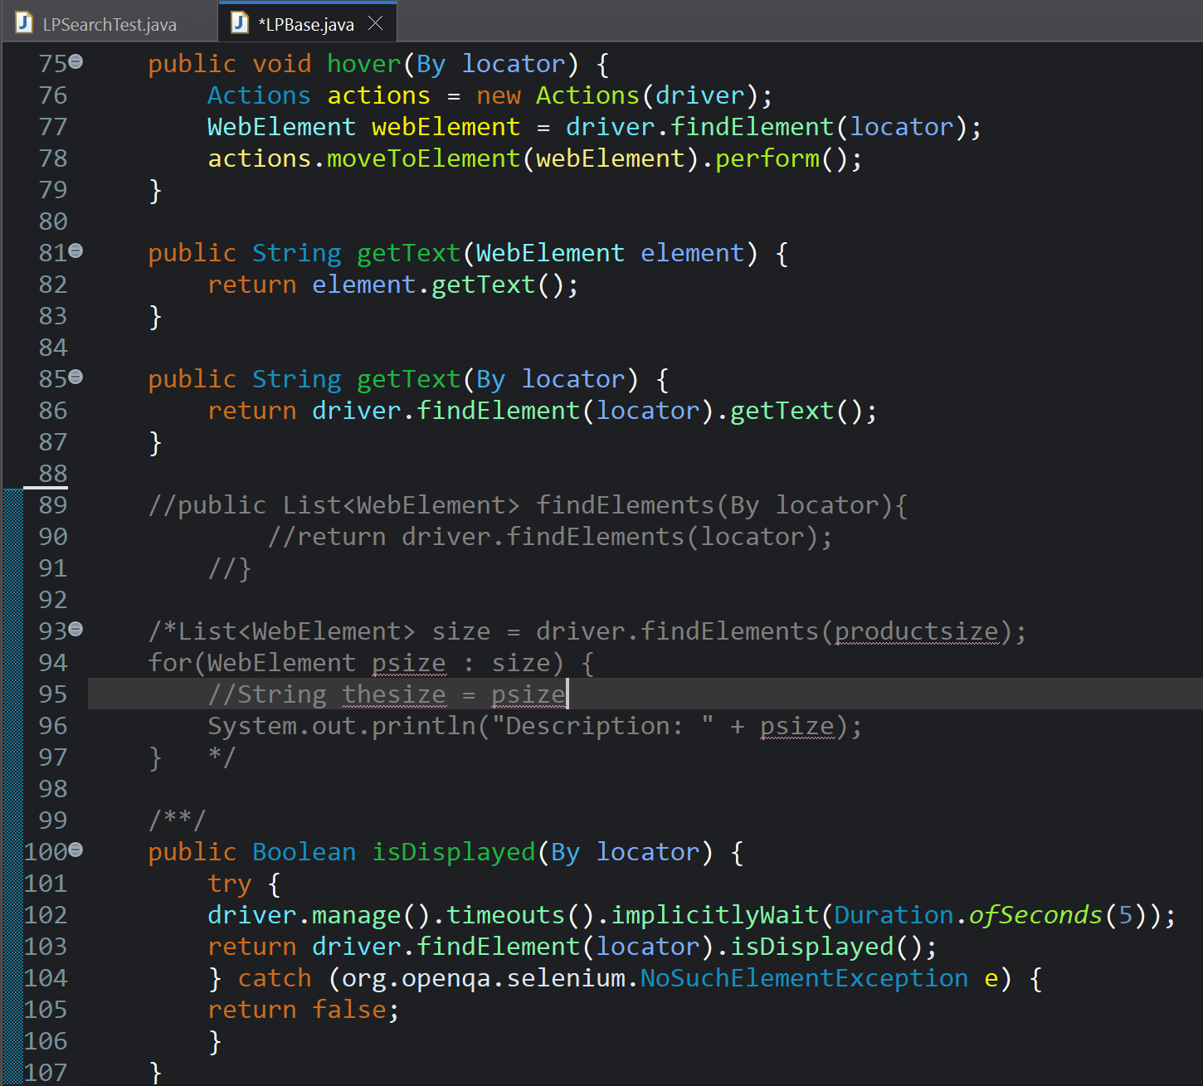
Up
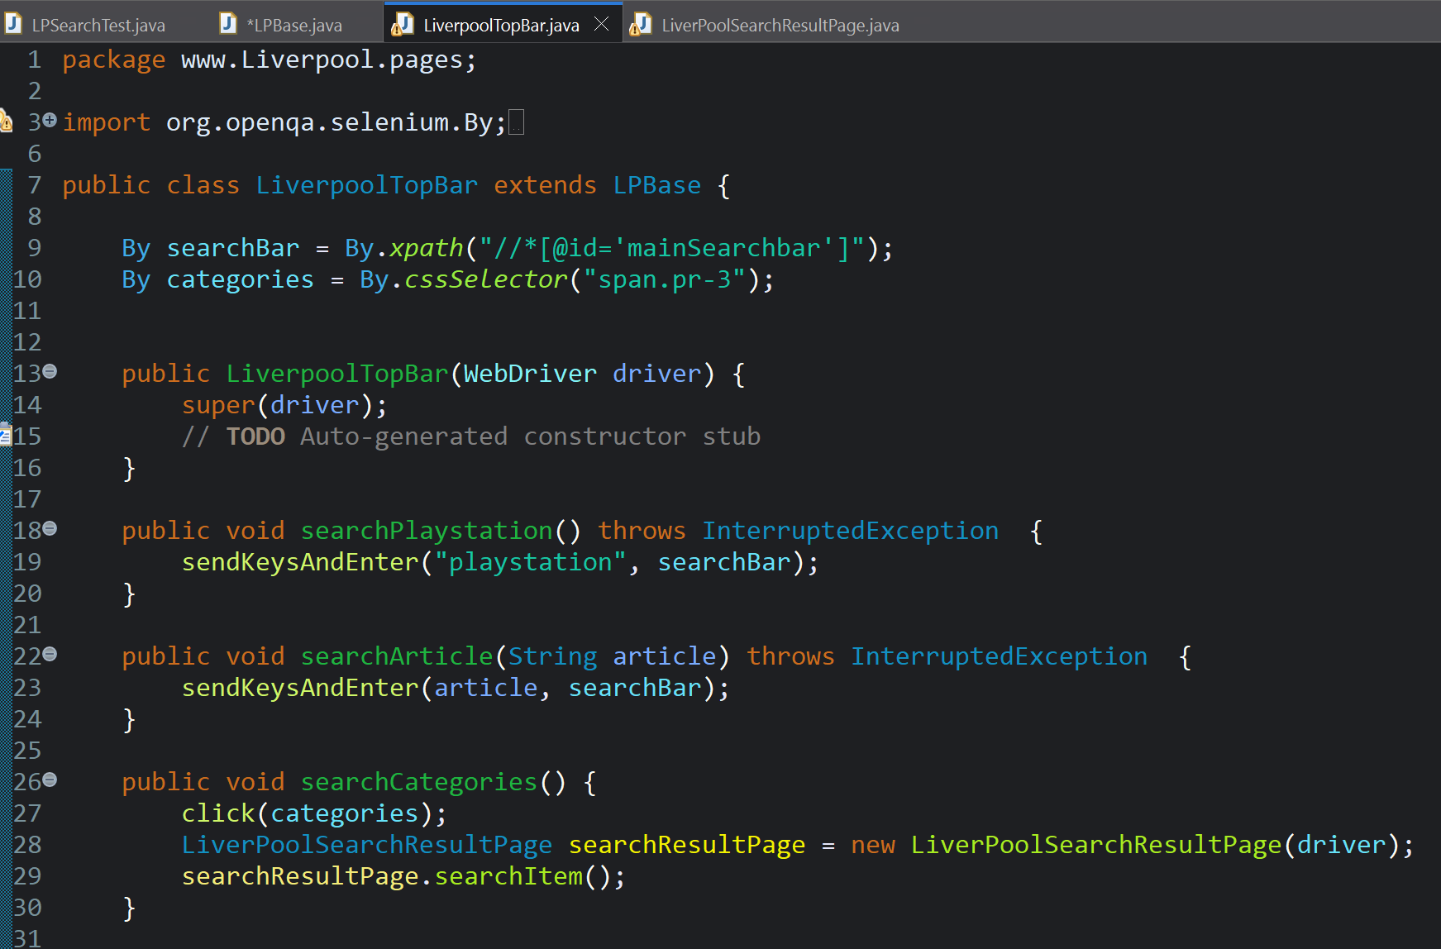

Locators
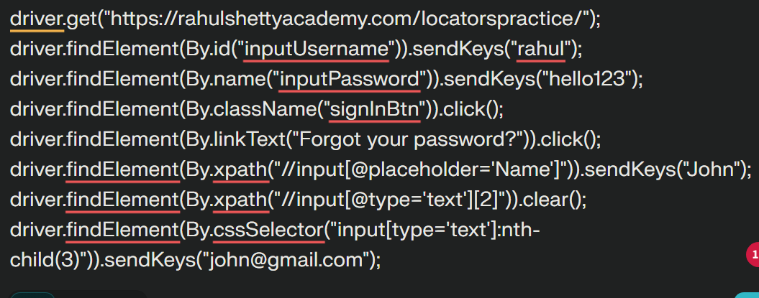
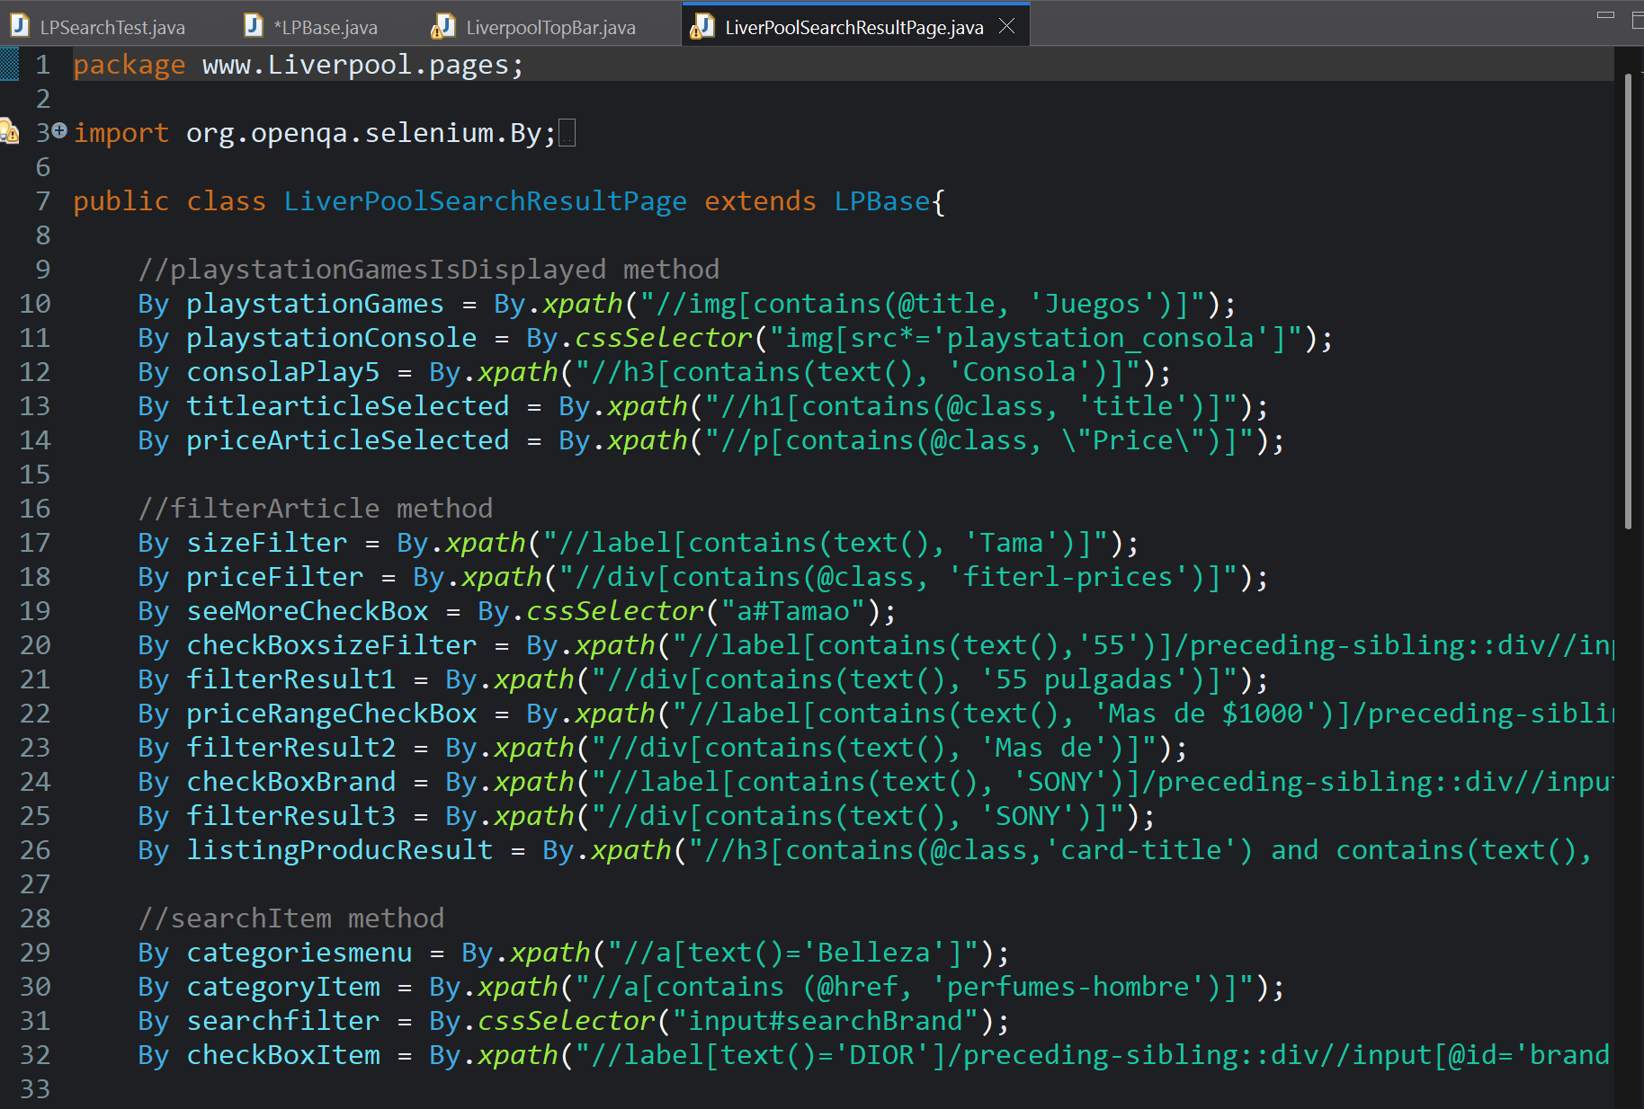

Exceptions

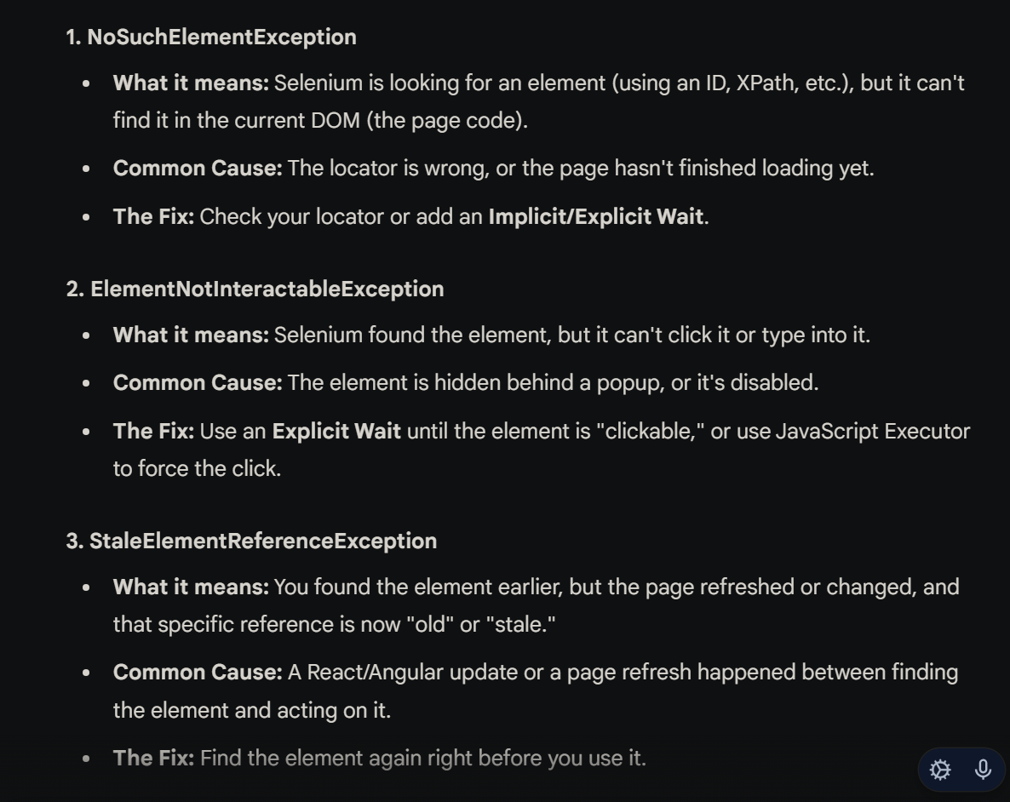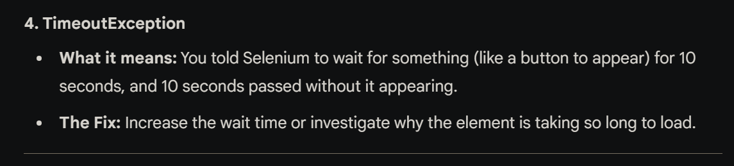
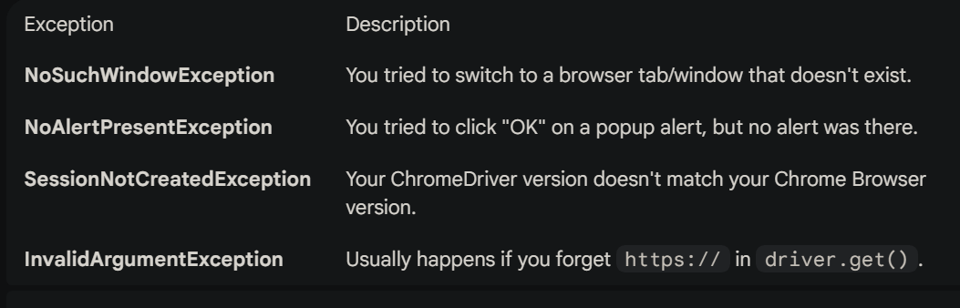
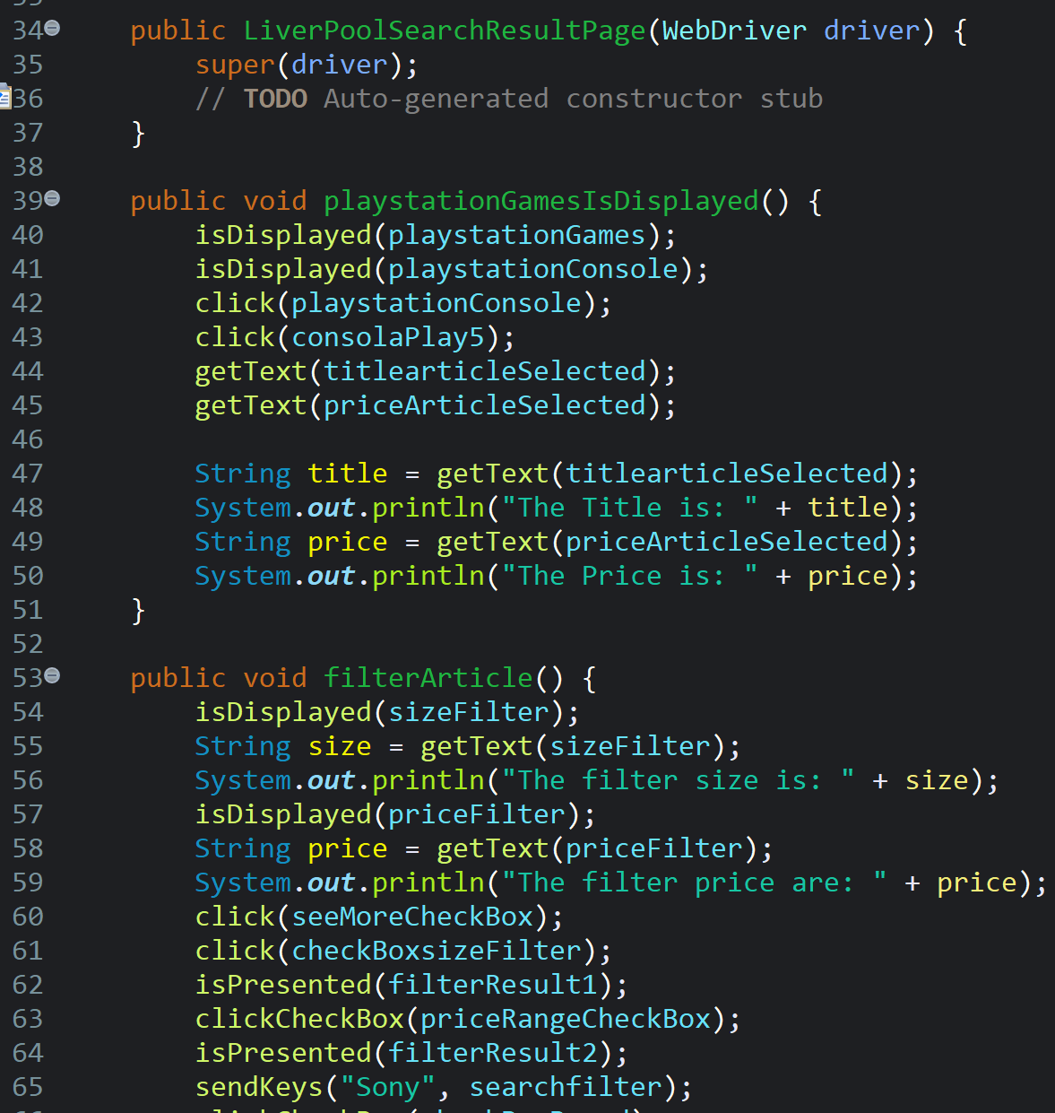
Up

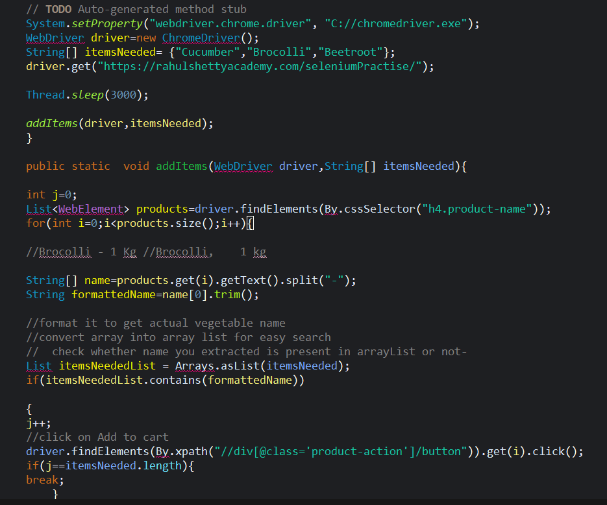
Up

Login
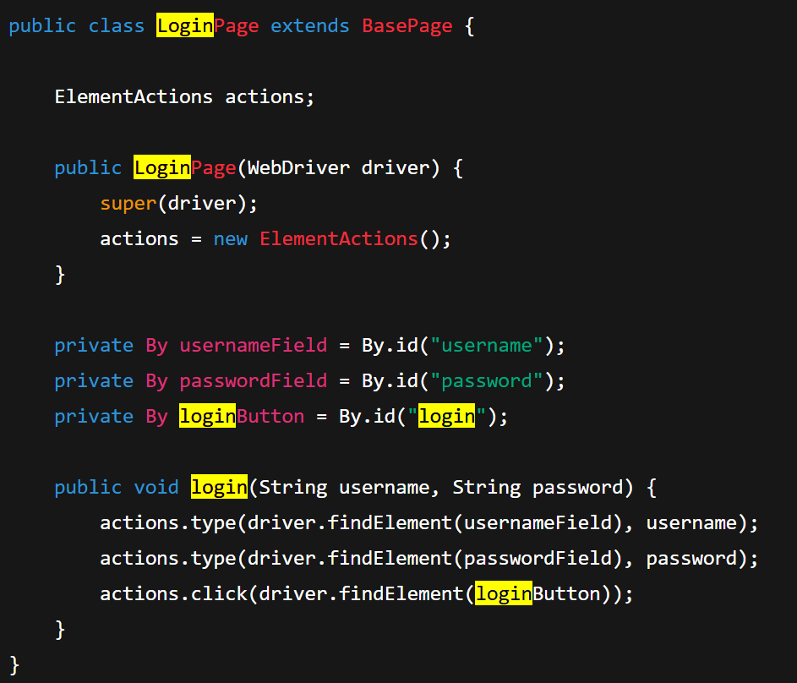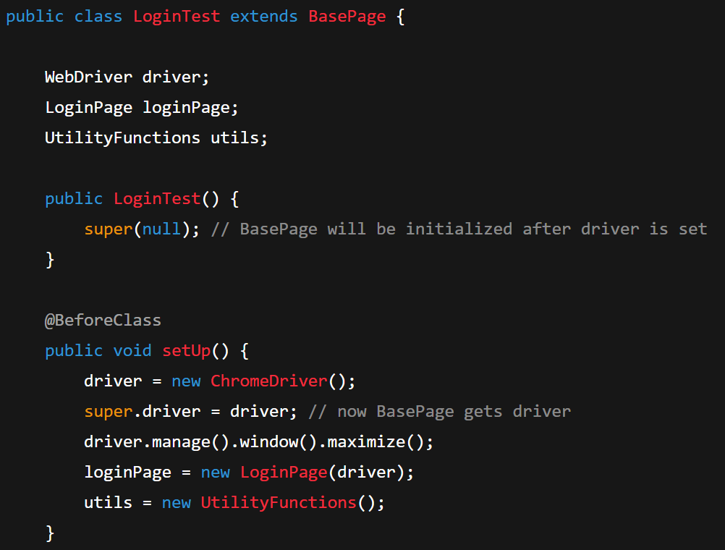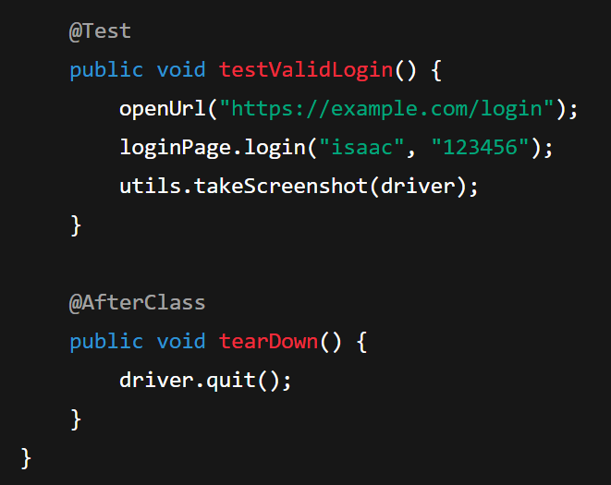

What is Selenium
Selenium is an open-source framework for automating web browser interactions. Its core tool, WebDriver, simulates user actions to test web applications efficiently.
Different components of Selenium.
Selenium WebDriver: It is the primary component that interacts with the browser and automates user actions.
Selenium IDE (Integrated Development Environment): It is a record-and-playback tool for creating test scripts.
Selenium Grid: It allows running tests on multiple machines or browsers in parallel.
Selenium Remote Control (RC): It is the predecessor of WebDriver and provides a way to execute tests in different browsers using JavaScript.

Locators in Selenium
Locator Type | Syntax Example | Description
ID | driver.findElement(By.id("username")) | Finds element with matching id attribute (must be unique).
Name | driver.findElement(By.name("email")) | Finds element by its name attribute.
Class Name | driver.findElement(By.className("btn")) | Finds element by class attribute (not always unique).
Tag Name | driver.findElement(By.tagName("input")) | Finds element by its HTML tag name (e.g., input, div).
Link Text | driver.findElement(By.linkText("Login")) | Finds anchor (<a>) tag with exact visible text.
Partial Link Text | driver.findElement(By.partialLinkText("Log")) | Finds anchor tag with partially matching link text.
CSS Selector | driver.findElement(By.cssSelector("div#main .btn")) | Very flexible — uses CSS syntax to match elements.
XPath | driver.findElement(By.xpath("//input[@type='text']")) | Most powerful; uses XML path expressions for locating elements.
Class locators
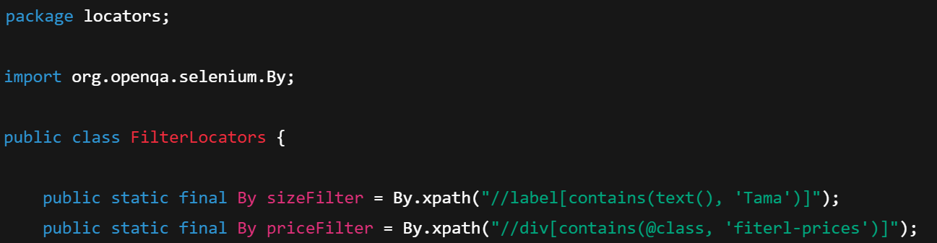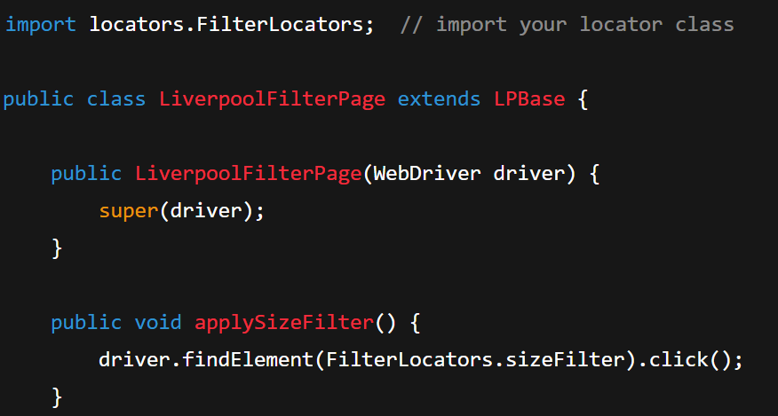

Data Driven Testing
Testing methodology where test data is separated from test scripts and stored externally (like in Excel, CSV, JSON, XML, or databases). The same test logic is executed multiple times with different sets of data to validate various input combinations and edge cases.
Example: TestNG by reading data from Excel files using Apache POI.
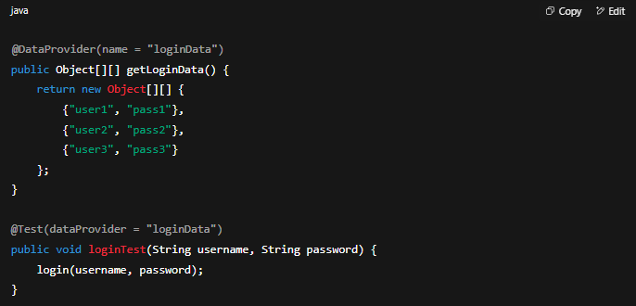

Difference between driver.close() and driver.quit()
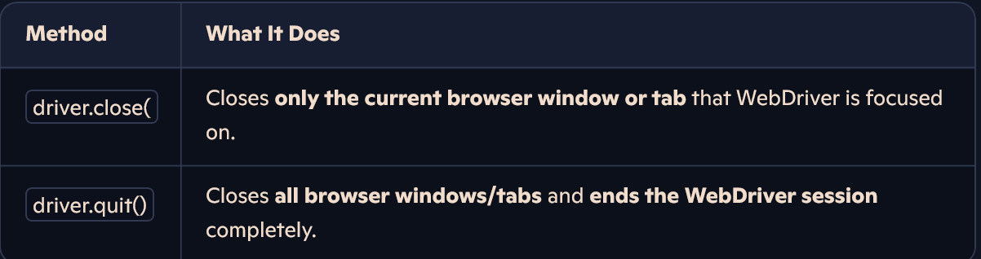
Explain the concept of Test Data in Selenium. How do you manage test data effectively?
Test Data refers to the input data used for test cases. It can include different test scenarios, valid/invalid data, boundary values, etc. Test data can be managed effectively by using external data sources such as CSV files, Excel sheets, or databases. By separating test data from test scripts, you can easily update or modify the data without changing the code.

Xpath types
Relative XPath: Starts with a reference to the current element and navigates to the desired element based on relationships within the DOM hierarchy.
Example: //div[@id='myDiv']//span[@class='myClass']
Absolute XPath: XPath expression that specifies the complete path from the root element to the desired element.
Example: /html/body/div[2]/div[1]/span[3]

CSS Selector

What is Maven
Maven is used in automation for dependency management, build automation, standardized project structure, automated test execution, and reporting, making the automation process more efficient and reliable.
Dependency Management: Maven simplifies managing project dependencies.
Build Lifecycle Management: Maven provides a predefined build lifecycle.
Consistent Project Structure: Maven enforces a standardized project structure.
Automated Build Process: Maven automates the build process.
Test Execution and Reporting: Maven integrates with testing frameworks and generates test reports.
Cross-Platform Compatibility: Maven is platform-independent and supports multiple programming languages.

Waits in Selenium:
Implicit wait sets a universal delay for locating elements throughout WebDriver.
Explicit wait targets specific elements, waiting until a custom condition is met or times out.
Implicit wait sets a global timeout for WebDriver to find elements.
Explicit wait targets specific elements, waiting for defined conditions before timing out.
Implicit Waits:
driver.manage().timeouts().implicitlyWait(10, TimeUnit.SECONDS);
Explicit Waits:
WebDriverWait wait = new WebDriverWait(driver, 10);
Selenium components
Selenium WebDriver: Allows interaction with web browsers, controlling navigation, element interaction, and retrieving information from web applications.
Selenium Grid: Enables parallel execution of tests across multiple machines or browsers, helping to speed up the test execution process.
Selenium IDE: Provides a record-and-playback feature for quickly creating basic test scripts by recording user interactions with the web application.
Selenium Client Libraries: Programming language-specific libraries that allow writing and executing automation scripts using Selenium.
Selenium WebDriver Bindings: Language-specific implementations of the WebDriver API that bridge the client libraries with WebDriver.
Browser Drivers: Specific drivers for each web browser that enable WebDriver to control and interact with the browser.
These components form the core of Selenium, enabling web automation testing across different browsers and platforms.

Types of testing
Unit testing:
A Unit is a smallest testable portion of system or application which can be compiled, liked, loaded, and executed. This kind of testing helps to test each module separately.
The aim is to test each part of the software by separating it. It checks that component are fulfilling functionalities or not. This kind of testing is performed by developers.
Integration testing:
Integration means combining. For Example, In this testing phase, different software modules are combined and tested as a group to make sure that integrated system is ready for system testing.
Integrating testing checks the data flow from one module to other modules. This kind of testing is performed by testers.
System Testing:
System testing is performed on a complete, integrated system. It allows checking system’s compliance as per the requirements. It tests the overall interaction of components. It involves load, performance, reliability and security testing.
System testing most often the final test to verify that the system meets the specification. It evaluates both functional and non-functional need for the testing.
Acceptance testing:
Acceptance testing is a test conducted to find if the requirements of a specification or contract are met as per its delivery. Acceptance testing is basically done by the user or customer. However, other stockholders can be involved in this process.
Edge testing:
Edge testing is a type of software testing that focuses on validating system behavior at the boundaries of input or functionality — where things are most likely to break or behave unexpectedly.

findElement() vs findElements()
findElement() returns the first matching element based on the given locator, while findElements() returns a list of all matching elements. If no element is found, findElement() throws a NoSuchElementException, whereas findElements() returns an empty list.

Handle dynamic elements or elements with dynamic IDs
To handle dynamic elements, you can use locators that are less likely to change, such as CSS selectors or XPath with specific attributes. You can also use relative locators like parent-child relationships or sibling relationships to navigate to the desired element.

How do you handle pop-up windows and alerts in Selenium?

To handle pop-up windows, you can use the getWindowHandles() method to get the handles of all windows, switch to the desired window using switchTo().window(handle), and perform actions on the window.
For alerts, you can use the Alert class in Selenium, which provides methods like accept(), dismiss(), and getText() to interact with alerts.
How do you handle frames and iframes in Selenium?

To handle frames and iframes, you can switch to them using the switchTo().frame() method by specifying the frame's name, index, or WebElement. Once inside the frame, you can perform actions on the elements present within it.
What are the advantages of using Selenium WebDriver over Selenium RC?

Selenium WebDriver overcame some limitations of Selenium RC by providing a more robust and intuitive API. WebDriver has a simpler and more concise API, supports more programming languages, and has better performance. It also eliminates the need for the Selenium RC server component.
What are the different types of waits available in Selenium WebDriver?

Handle dropdowns or select options
To handle dropdowns, you can use the Select class in Selenium. Instantiate a Select object with the dropdown element, and then you can select options by value, index, or visible text using methods like selectByValue(), selectByIndex(), or selectByVisibleText().
How can you handle multiple windows in Selenium?
To handle multiple windows, you can use the getWindowHandles() method to get all window handles. Store the handles in a set, switch to the desired window using switchTo().window(handle), and perform actions on the window. You can switch back to the original window by keeping track of its handle.

Multiple Windows
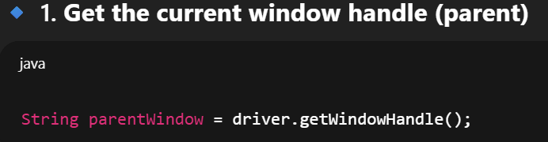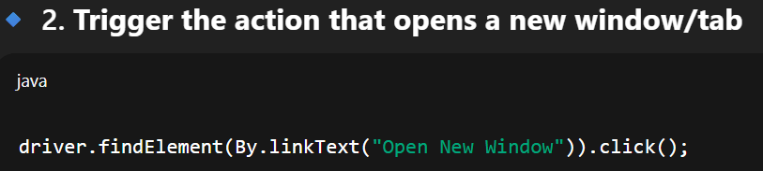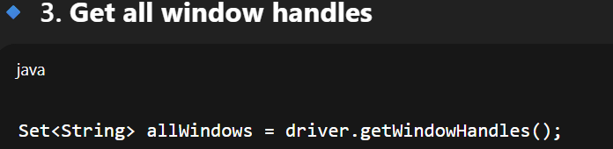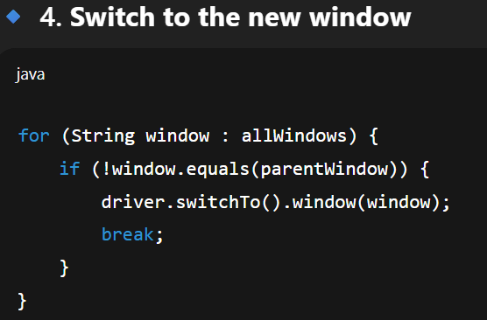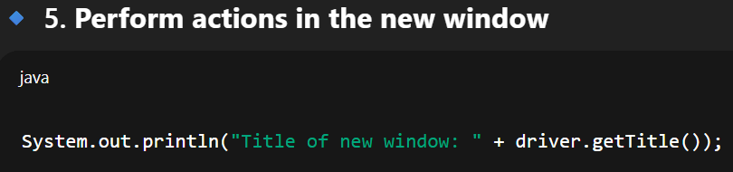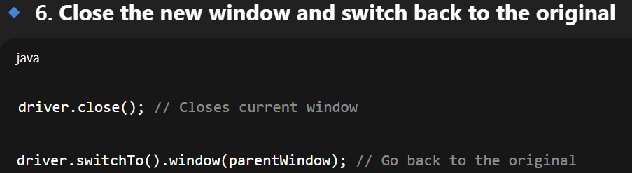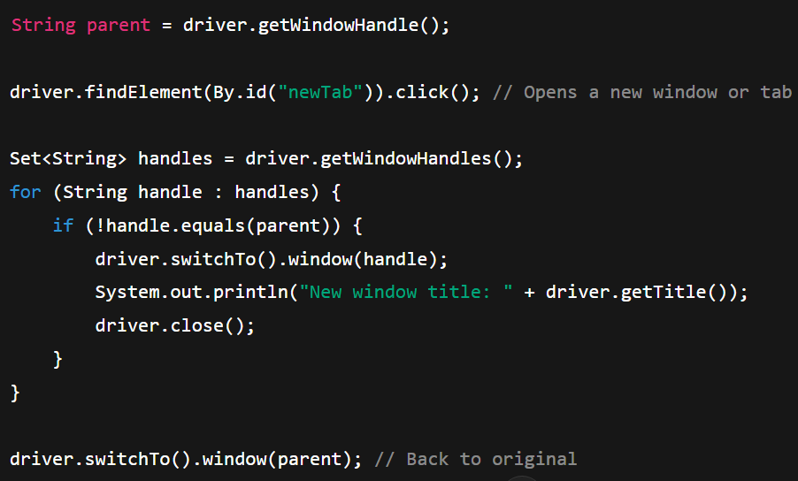

Page Object Model (POM)
Is a design patter where you divide the web pages into classes to help organize and maintain the code
Encapsulating the page's elements and actions within the class.
The benefits of POM include better code modularity, reusability, and maintainability.
It also promotes a cleaner separation between test logic and page-specific details such as object locators which are stored separately in a separate class and then the test methods are stored separately.

How do you handle browser cookies in Selenium?
Selenium WebDriver provides the addCookie() and deleteCookie() methods to handle browser cookies. You can create a Cookie object with the desired values and use the addCookie() method to add it to the current browser session. To delete a cookie, use the deleteCookie() method with the cookie's name or object.

What is TestNG
TestNG is a testing framework for Selenium that supports parallel execution, dependencies, and data-driven testing. It uses annotations (like @Test) and runs tests via the TestNG runner.
TestNG offers advantages over JUnit like better data-driven testing, parallel execution, XML-based configuration, advanced reporting, and support for test grouping and prioritization.
File uploads in Selenium
To handle file uploads, you can use the sendKeys() method on the file input element. Provide the full file path as an argument to the method, and it will simulate a user selecting the file for upload.

Test Data in Selenium. How do you manage test data effectively?
Test Data refers to the input data used for test cases. It can include different test scenarios, valid/invalid data, boundary values, etc. Test data can be managed effectively by using external data sources such as CSV files, Excel sheets, or databases. By separating test data from test scripts, you can easily update or modify the data without changing the code.
How do you handle synchronization issues in Selenium?
Synchronization issues can occur when an element is not immediately available or takes time to load. To handle synchronization, you can use explicit waits with conditions like elementToBeClickable(), visibilityOfElementLocated(), or custom conditions. This ensures that the necessary elements are loaded before performing actions on them.
Screenshots in Selenium
By using the getScreenshotAs() method provided by WebDriver.

APPIUM
What is Appium, and how does it work?
Appium is an open-source automation framework used for testing mobile applications on Android and iOS platforms. It allows you to write automated tests using the WebDriver protocol, providing a unified API to interact with mobile devices. Appium works by utilizing the respective platform's automation technologies (e.g., UIAutomator for Android, XCUITest for iOS) to automate user interactions.
Explain the difference between Appium and other mobile automation tools.

Unlike other mobile automation tools, Appium offers cross-platform support, allowing you to write tests once and execute them on both Android and iOS platforms. It uses the standard WebDriver protocol, making it compatible with different programming languages and frameworks. Appium also supports automation of native, hybrid, and web applications, providing a versatile testing solution.
What are the main components of Appium architecture?
The main components of Appium architecture include:
Appium Server: Acts as a bridge between the client and mobile device, manages the WebDriver sessions, and interprets the client's commands.
Appium Clients: Libraries or frameworks that communicate with the Appium Server using the WebDriver protocol. They provide language-specific bindings to write automation scripts.
Mobile Devices: The physical or virtual devices on which the mobile applications are installed and tested.
Automation Drivers:
Platform-specific tools (e.g., UIAutomator for Android, XCUITest for iOS) that interact with the mobile device's automation interface and perform actions on the application.
How do you set up and configure Appium for mobile automation testing?

To set up and configure Appium, you need to:
Install Appium using npm (Node Package Manager).
Install the necessary platform-specific tools (e.g., Android SDK, Xcode) and set up their environment variables.
Connect a physical device or start an emulator/simulator.
Start the Appium Server either through the command line or programmatically.
Configure desired capabilities, including device details, application path, platform, etc., in your automation script.
What are the different locator strategies used in Appium?
Appium supports various locator strategies to identify elements on a mobile application:
id: Locates elements using the resource-id attribute.
class name: Locates elements using the class attribute.
accessibility id: Locates elements using the content-desc attribute.
xpath: Locates elements using XPath expressions.
android uiautomator: Locates elements using the Android UIAutomator framework.
iOS predicate string: Locates elements using predicates in iOS.
How do you handle native, hybrid, and web applications in Appium?

Appium provides different contexts to handle different types of applications:
Native Applications: Appium interacts with the native elements and their properties directly using the platform-specific automation frameworks (e.g., UIAutomator for Android, XCUITest for iOS).
Hybrid Applications: Appium treats hybrid applications as a combination of native and web elements. It switches the context between the native and web views to perform actions accordingly.
Web Applications: Appium uses the WebView context to automate web elements within a mobile application. It utilizes the underlying browser automation frameworks like Selenium WebDriver.

SetUP
Install appium with the command terminal by following instructions:
https://appium.io/docs/en/2.0/quickstart/install/
Install appium doctor:
https://www.npmjs.com/package/appium-doctor

Gestures and touch actions
Appium allows automation of gestures and touch actions using the TouchAction and MultiTouchAction classes. You can perform actions like tap, press, swipe, scroll, pinch, and zoom on mobile elements

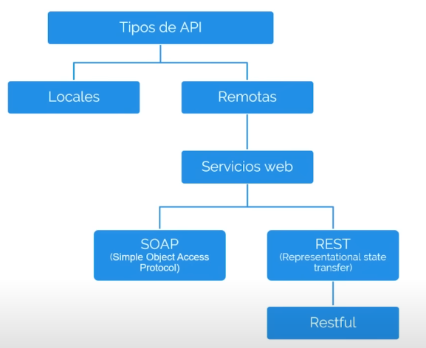

Test types
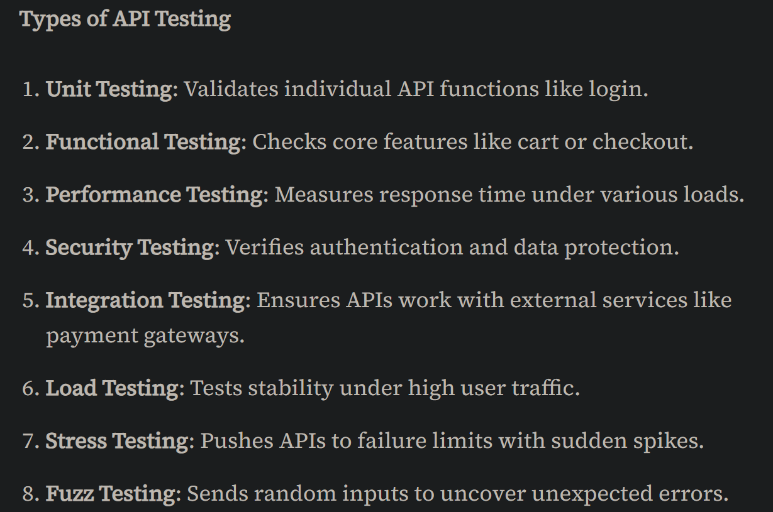

HTTP Status code families
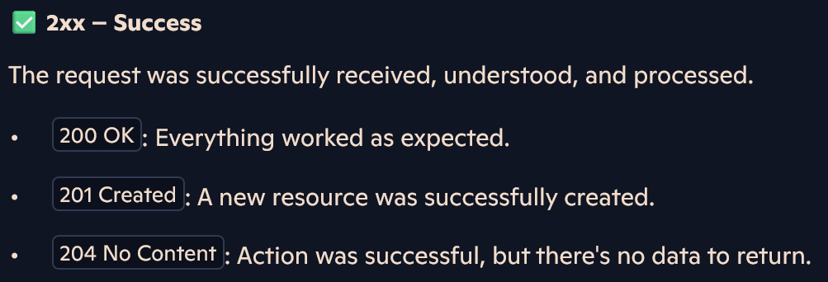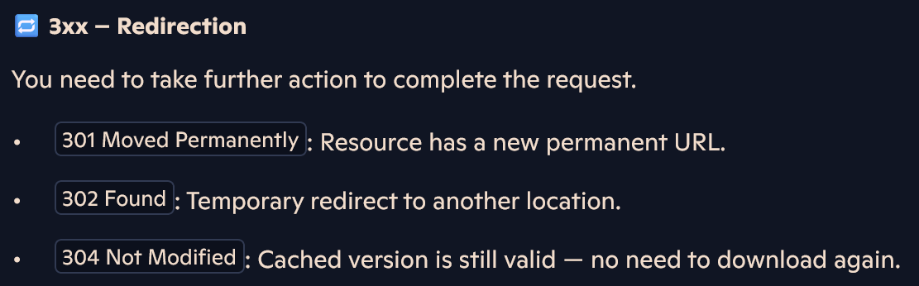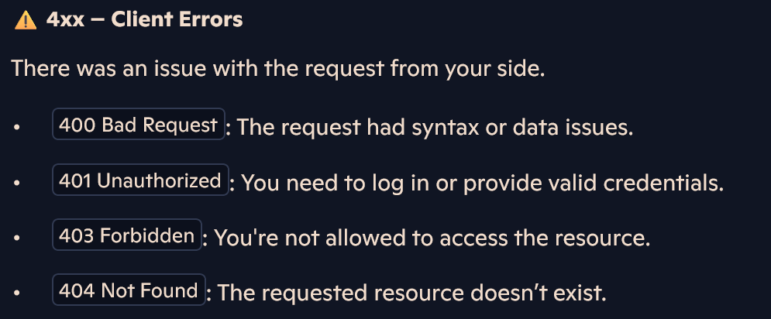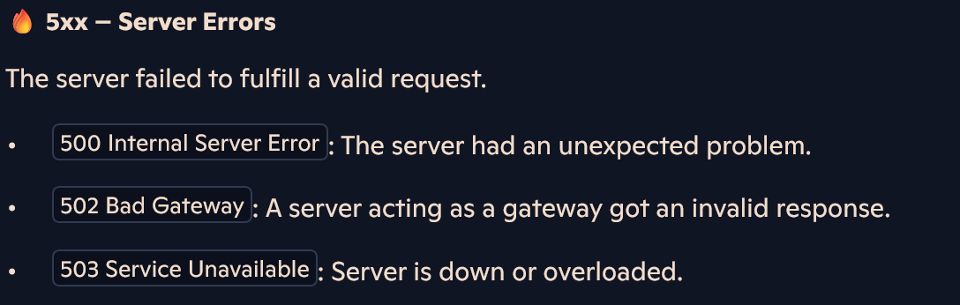

HTTP Methods
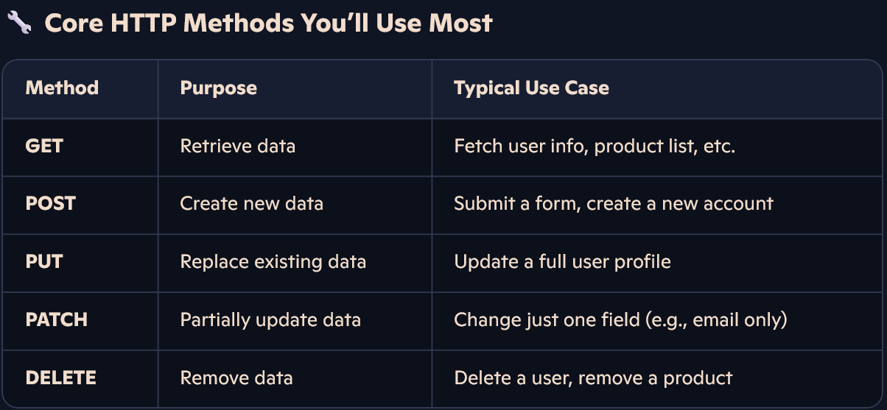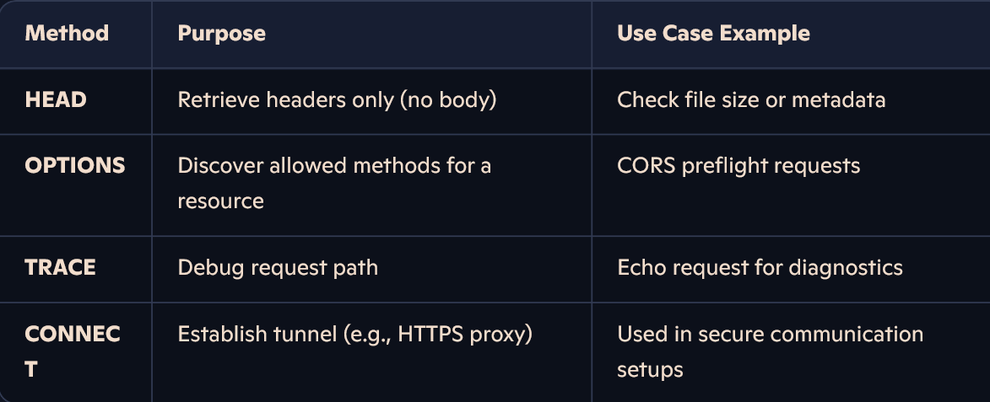

Pagination
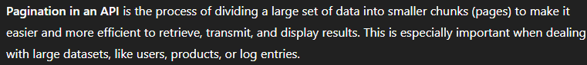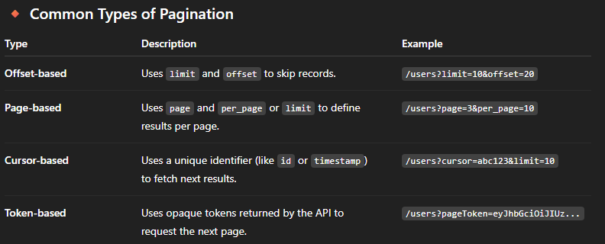

For SCRUM
How does the Scrum process work within your organization? Can you walk me through the typical ceremonies, roles, and artifacts involved?
What is the role of a QA SDTE in a Scrum team, and how do they collaborate with other team members?
How does the organization ensure that the QA SDTE's tasks and responsibilities are well-defined and integrated into the Scrum workflow?
How are user stories and acceptance criteria defined and communicated within the Scrum team?
Can you share an example of how the QA SDTE participates in Sprint Planning and helps determine the work that can be accomplished within a sprint?
How does the organization handle changing requirements or new feature requests during a sprint? How does it impact the QA SDTE's work?
What strategies does the organization use to ensure effective communication and collaboration between the QA SDTE, developers, and the Product Owner?
How is progress tracked and reported within the Scrum framework? How are the QA SDTE's contributions measured and evaluated?
Are there any specific metrics or key performance indicators (KPIs) that the organization tracks to assess the quality and effectiveness of the QA SDTE's work?
How does the Scrum team handle impediments or roadblocks that affect the QA SDTE's ability to complete their tasks?
Can you share an example of how the organization promotes continuous improvement and learning within the Scrum team, particularly for the QA SDTE role?
How does the organization ensure that quality assurance and testing activities are incorporated into each sprint, rather than being treated as a separate phase at the end?
Are there any specific challenges or areas of improvement that the organization is currently focusing on in terms of implementing Scrum and integrating the QA SDTE role effectively?
How does the Scrum team handle retrospectives and incorporate feedback to improve the QA SDTE's processes and workflows?
What opportunities for career growth and advancement are available for a QA SDTE in a Scrum environment within the company?

Selenium questions:
1. What is data driven framework?
2. How we create the hybrid framework?
4. Different types of objects identification process?
7. Version of a dependency changes frequently. To update dependencies, what needs to be done?
8. What are the different Maven Repositories
9. How would you refer to a property declared in your pom.xml file?
11. How to wait until a web page has been loaded completely in Selenium?
12. Mention different ways of locating an element in Selenium?

